Week 01-0:

--Coding-C-Language Features-Optional.

ROLL NO.:241801296

Name: THARUNIKA. R

Q1) Given below is a simple program written in C language. Change the text in the code given below to make the program print “Hello C” instead of “Hello B”. Answer: (penalty regime: 0%)

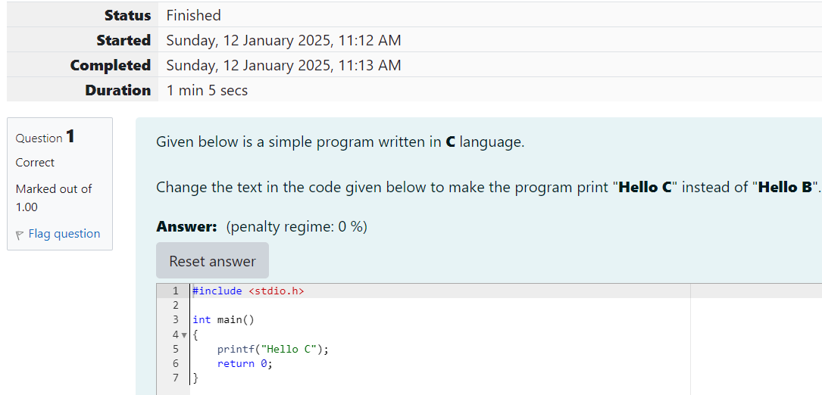

OUTPUT:

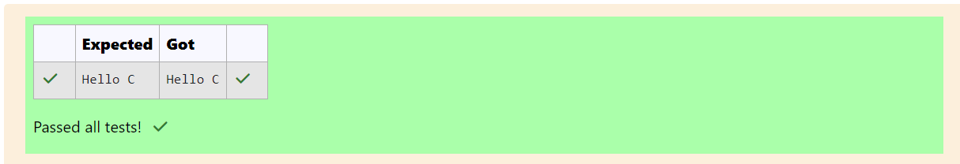

Q2) The code given below contains instructions to print the text “I love Apples” to the console.

The \n in the text “I love Apples\n” ensures that the line breaks after printing the text “I love Apples” (which means that nothing else is printed on the same line). Follow the steps given below to change the text, execute compile command and finally execute the file: 1. In the code given below, change the text to print “I love Mangoes” instead of “I love Apples”. Answer: (penalty regime: 0 %)

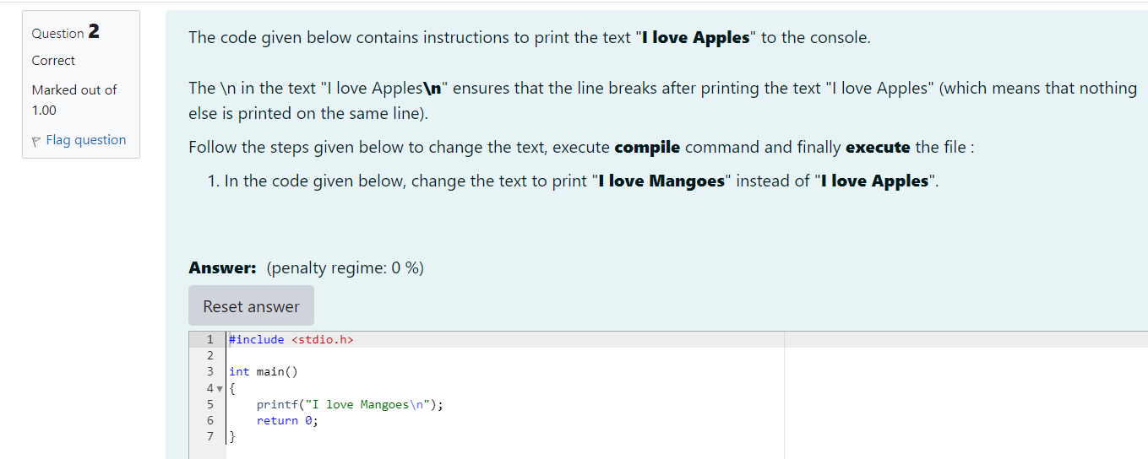

OUTPUT:

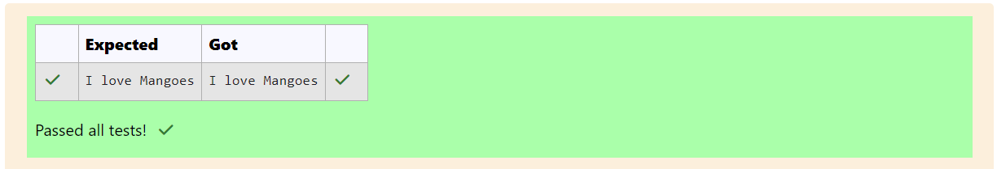

Week 01 -01:

--Practice Session – Coding.

ROLL NO: 241801296

Name: THARUNIKA. R

Q1) This is a simple challenge to help you practice printing to stdout. We’re starting out by printing the most famous computing phrase of all time! In the editor below, use either printf or cout to print the string Hello, World! To stdout. Input Format You do not need to read any input in this challenge. Output Format Print Hello, World! to stdout. Sample Output Hello, World! Answer: (penalty regime: 0 %)

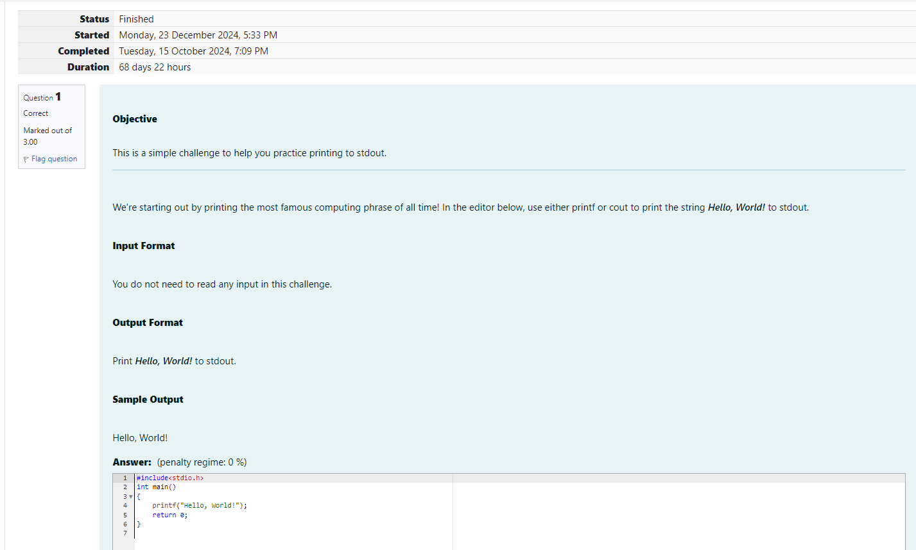

OUTPUT:

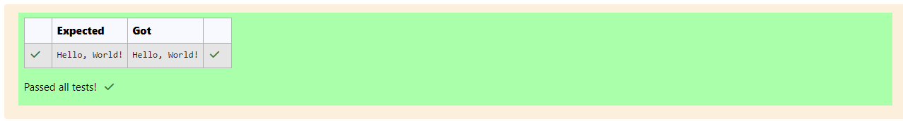

Q2) Objective This challenge will help you to learn how to take a character, a string and a sentence as input in C. To take a single character ch as input, you can use scanf(“%c”, &ch); and printf(“%c”, ch) writes a character specified by the argument char to stdout: char ch; scanf(“%c”, &ch); printf(“%c”, ch); This piece of code prints the character ch. Task You have to print the character , ch. Input Format Take a character, ch as input. Output Format Print the character, ch. Answer: (penalty regime: 0 %)

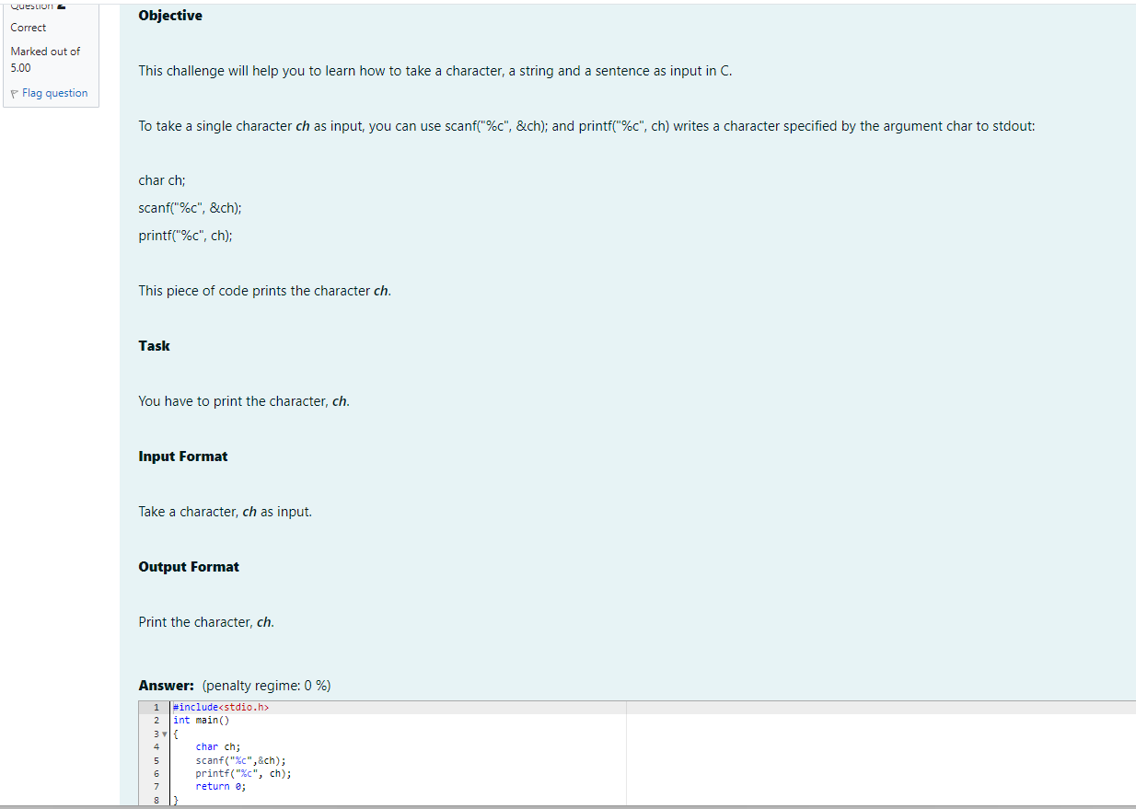

OUTPUT:

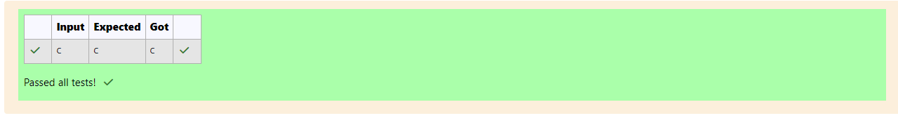

Q3) Objective The fundamental data types in C are int, float and char. Today, we’re discussing int and float data types. The print() function prints the given statement to the console. The syntax is printf (“format string”, argument_list);. In the function, if we are using an integer, character, string or float as argument, then in the format string we have to write %d (integer), %c (character), %s (string), %f (float) respectively. The scanf() function reads the input data from the console. The syntax is scanf(“format string”, argument_list);. For ex: The scanf(“%d”, &number) ststement reads integer number from the console and stores the given value in variable number. To input two integers separated by a space on a single line, the command is scanf(“%d %d”, &n, &m),where n and m are the two integers. Task Your task is to take two numbers of int data type, two numbers of float data type as input and output their sum: 1. Declare 4 variables: two of type int and two of type float. 2. Read 2 lines of input from stdin (according to the sequence given in the ‘Input Format’ section below and initialize your 4 variables. 3. Use the + and – operator to perform the following operations: Print the sum and difference of two int variable on a new line. Printf the sum and difference of two float variable rounded to one decimal place on a new line. Input Format The first line contains two integers. The second line contains two floating point numbers. Constraints 1 <= integer variables <= 10^4 1 <= float variables <= 10^4 Output Format Print the sum and difference of both integers separated by a space on the first line, and the sum and difference of both float (scaled to 1 decimal place) separated by a space on the second line. Sample Input 10 4 6.0 2.0 Explanation When we sum the integers 10 and 4, we get the integer 14. When we subtract the second number 4 from the first number 10, we get 6 as their difference. When we sum the floating – point numbers 4.0 and 2.0, we get 6.0. When we subtract the second number 2.0 from the first number 4.0, we get 2.0 as their difference. Answer: (penalty regime: 0 %)

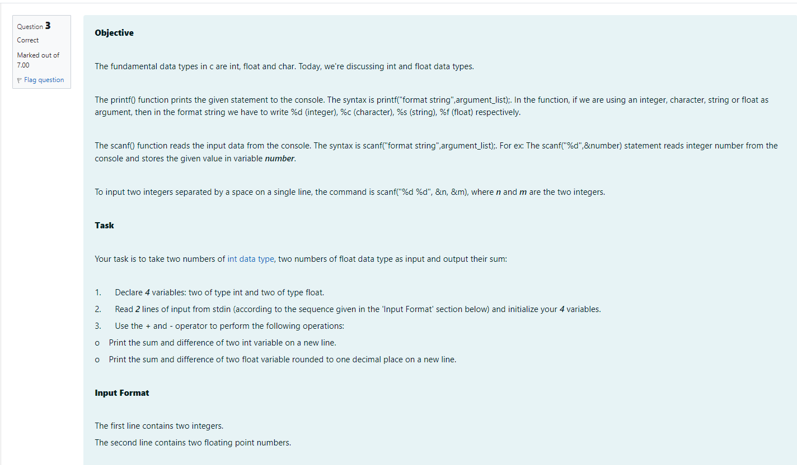

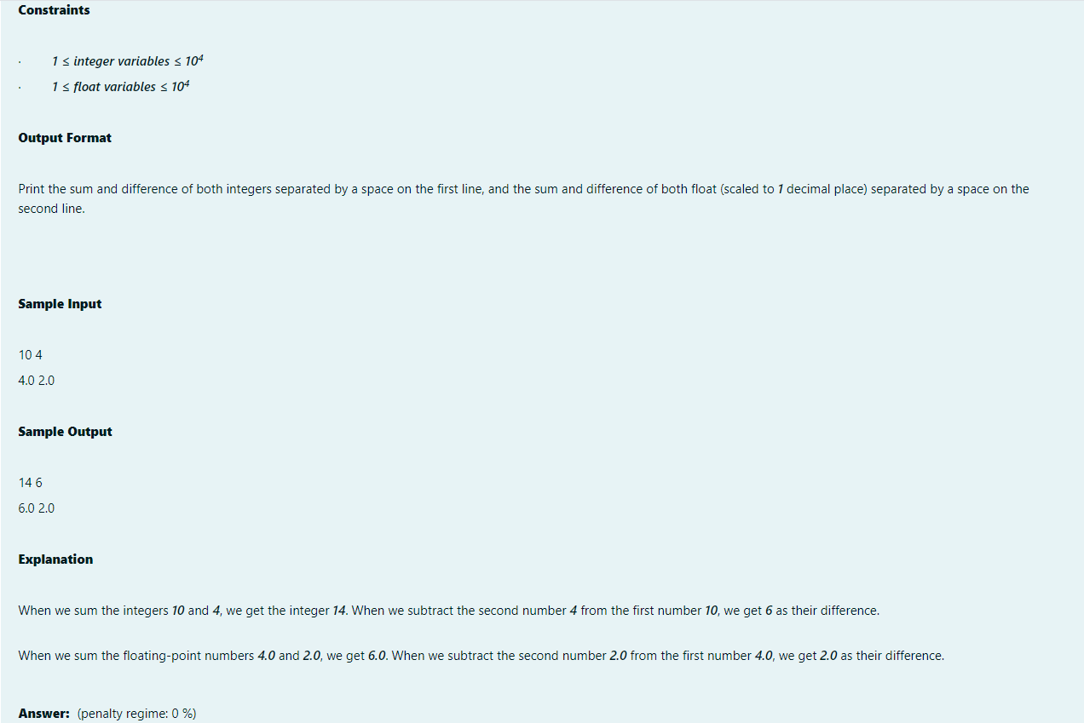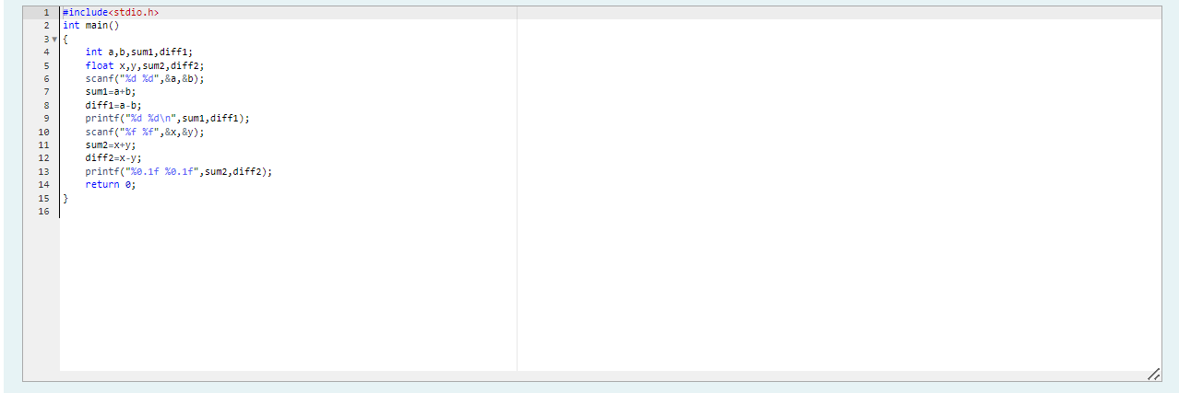

OUTPUT:

